SPEED AND DENSITY
OCR GSCE – Monday 9 November 2020 – Paper 6 (Calculator) Higher Tier
1.
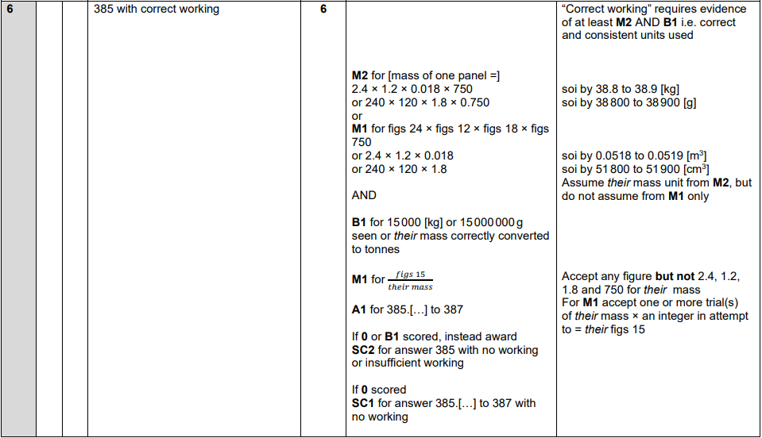
OCR GSCE – Monday 11 November 2019 – Paper 6 (Calculator) Higher Tier
2.
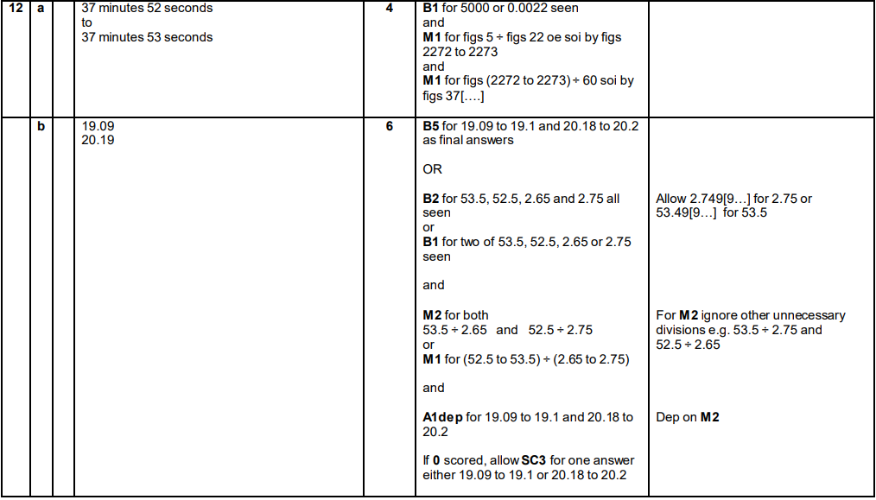
OCR GSCE – Thursday 8 November 2018 – Paper 5 (Non-Calculator) Higher Tier
3.
OCR GSCE – Tuesday 13 June 2017 – Paper 6 (Calculator) Higher Tier
4.
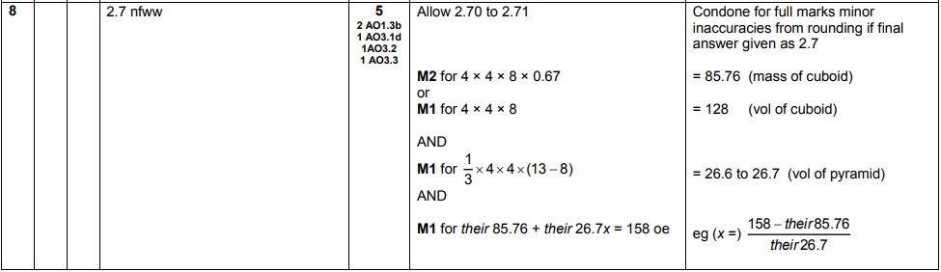

OCR GSCE – Sample Papers – Paper 5 (Non - Calculator) Higher Tier
5.
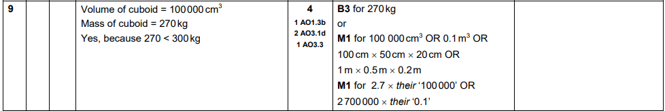
OCR GSCE – Sample Papers – Paper 6 (Calculator) Higher Tier
6.
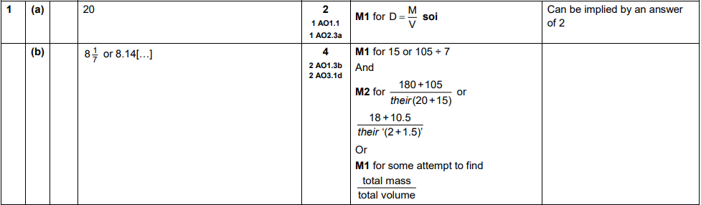
AQA GSCE – Thursday 4 June 2020 – Paper 2 (Calculator) Higher Tier
7.
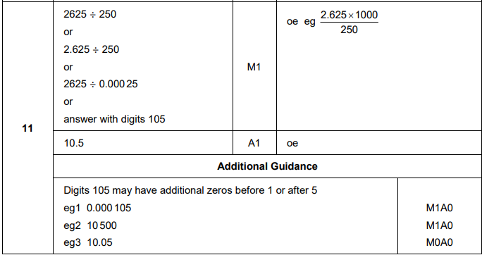

AQA GSCE – Thursday 6 June 2019 – Paper 2 (Calculator) Higher Tier
8.
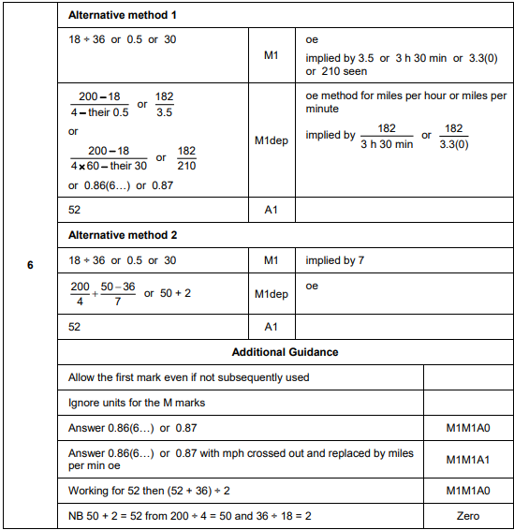
AQA GSCE – Tuesday 11 June 2019 – Paper 3 (Calculator) Higher Tier
9.
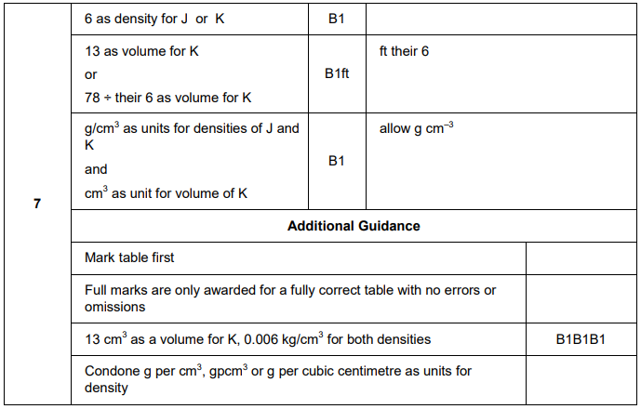
AQA GSCE – Thursday 7 June 2018 – Paper 2 (Calculator) Higher Tier
10.
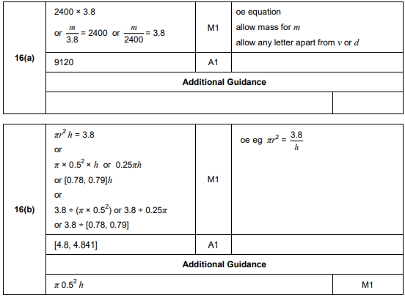
AQA GSCE – Thursday 7 June 2018 – Paper 2 (Calculator) Higher Tier
11.
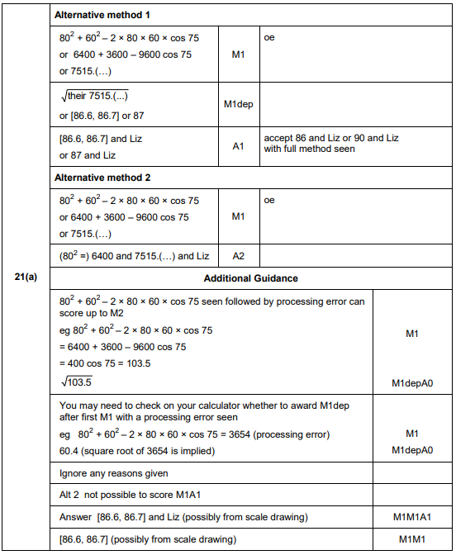
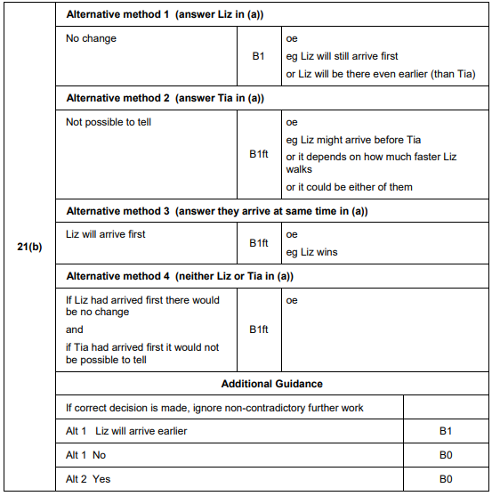
AQA GSCE – Wednesday 25 May 2017 – Paper 1 (Non - Calculator) Higher Tier
12.
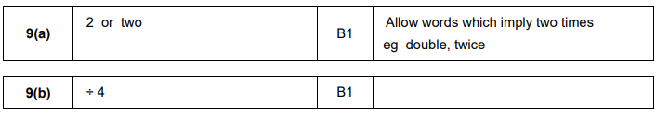
AQA GSCE – Tuesday 13 June 2017 – Paper 3 (Calculator) Higher Tier
13.
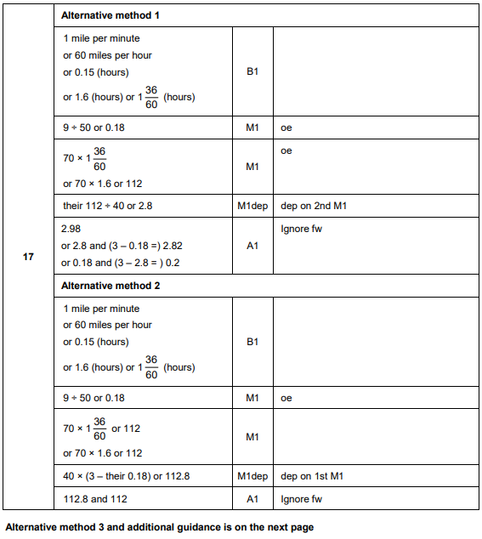
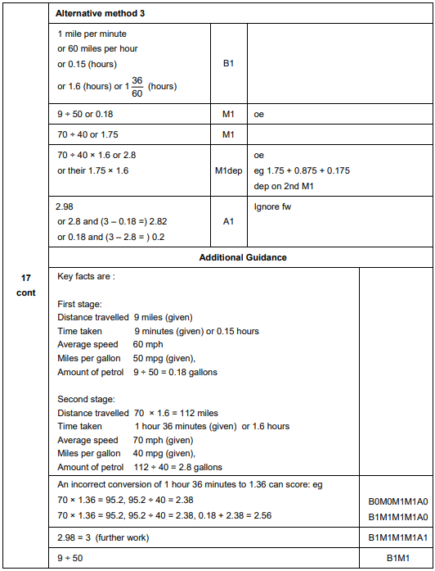
AQA GSCE – Sample Paper 2 (Calculator) Higher Tier
14.
